Gitea Experimental Operation Steps Document

Experimental Environment

•Operating System: Linux/Windows/macOS

•Tool: Docker Desktop

•Experimental Objective: Install Gitea using Docker and complete related experimental tasks

1. Installing Docker Desktop

1.1 Download and Installation

Windows/macOS:

1. Visit the Docker website: https://www.docker.com/products/docker-desktop

2. Download the Docker Desktop installation package for the corresponding operating system

3. Run the installer and follow the prompts to complete the installation

4. Start Docker Desktop

Linux:

# Ubuntu/Debiansudo apt-get updatesudo apt-get install docker.io docker-compose

# Start Docker servicesudo systemctl start dockersudo systemctl enable docker

1.2 Register a Docker Hub Account.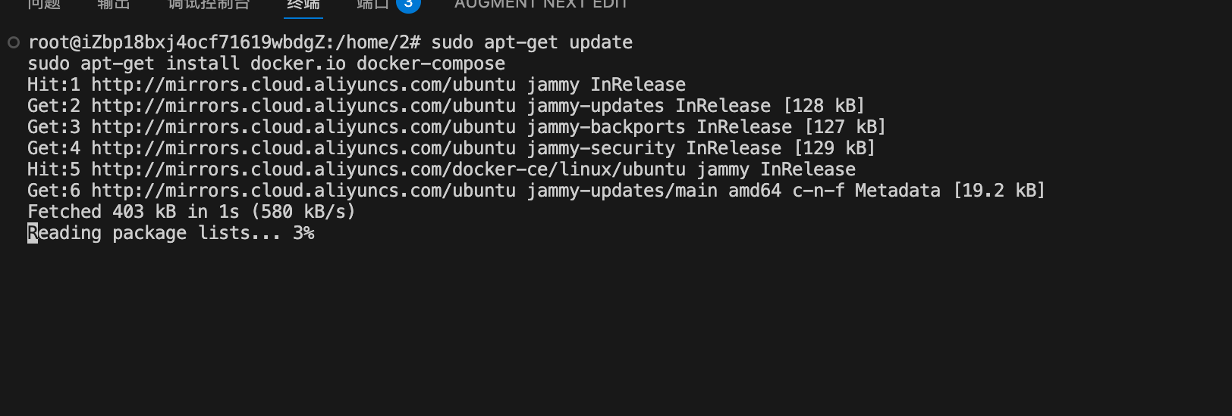
1. Visit: https://hub.docker.com/
2. Click "Sign Up" to register an account
3. Log in to the account in Docker Desktop
1.3 Verify Installation
docker --versiondocker-compose --version

2. Installing Gitea Using Docker
2.1 Create Working Directory
cd /home/2mkdir gitea-dockercd gitea-docker
2.2 Create docker-compose.yml File
version: "3"
networks: gitea: external: false
services: server: image: gitea/gitea:latest container_name: gitea environment: - USER_UID=1000 - USER_GID=1000 - GITEA__database__DB_TYPE=sqlite3 - GITEA__server__DOMAIN=localhost - GITEA__server__ROOT_URL=http://localhost:3000/ - GITEA__server__LFS_START_SERVER=true restart: always networks: - gitea volumes: - ./gitea:/data - /etc/timezone:/etc/timezone:ro - /etc/localtime:/etc/localtime:ro ports: - "3000:3000" - "222:22"
2.3 Start Gitea Container
docker-compose up -d
2.4 Check Container Status
docker psdocker logs gitea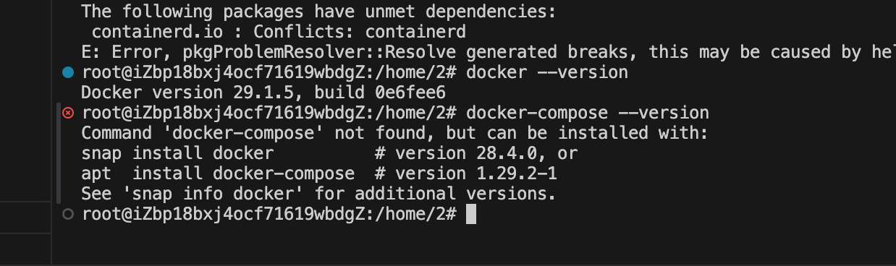
2.5 Access Gitea
1. Open your browser and visit: http://localhost:3000
2. The first visit will take you to the initialization configuration page
3. Configure the administrator account:
o Username: admin
o Password: Set a strong password (at least 8 characters)
o Email: your-email@example.com
4. Click "Install Gitea" to complete the initialization

三、Experimental Tasks
Task a: Verify whether Gitea supports Git LFS
Method 1: Check the configuration file
# Enter the containerdocker exec -it gitea bash
# View configurationcat /data/gitea/conf/app.ini | grep -A 5 "\[lfs\]"
Expected output:
[lfs]STORAGE_TYPE = localPATH = /data/git/lfs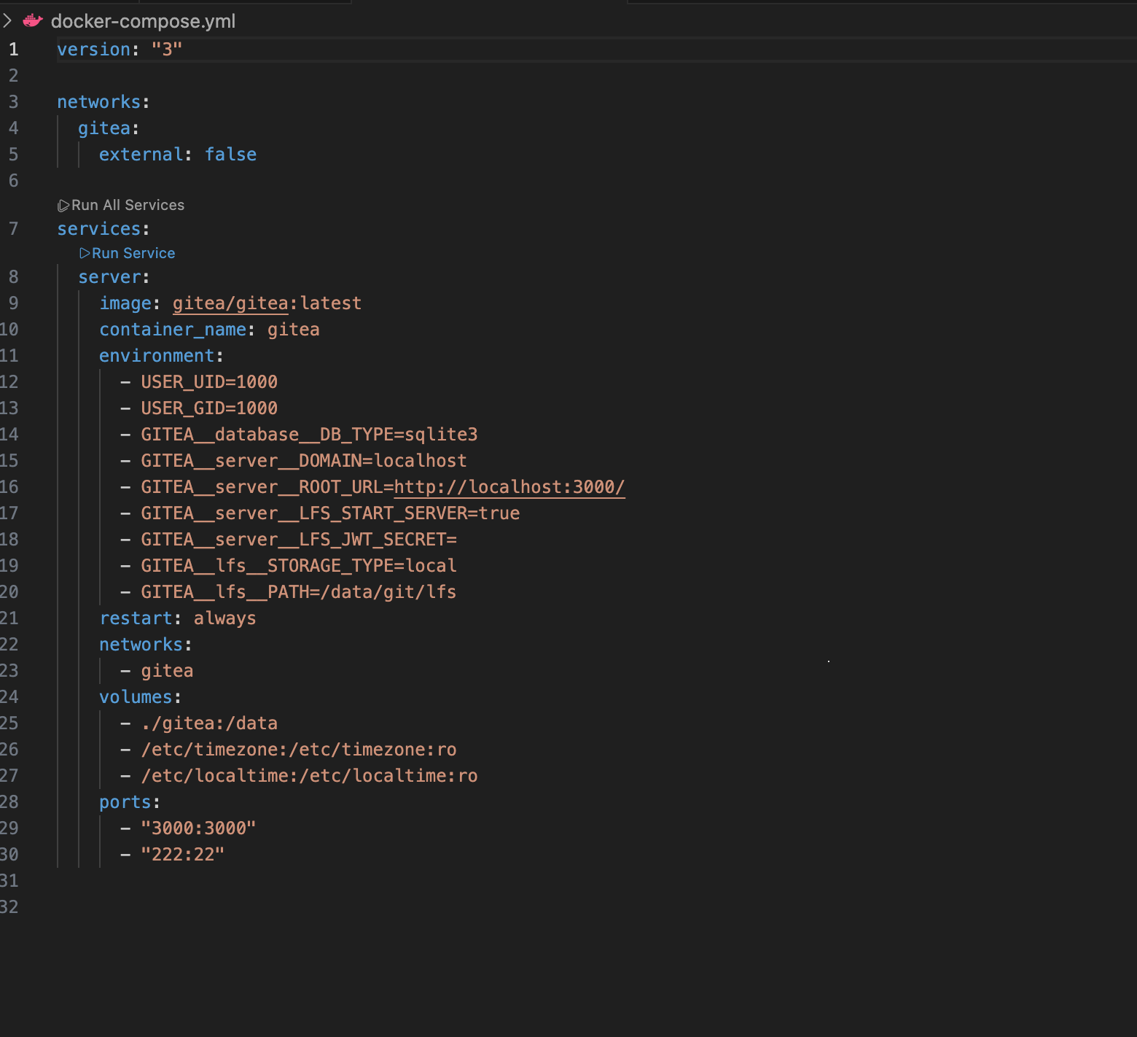
Method 2: Verify via Web Interface
1. Log in to Gitea
2. Navigate to "Site Administration" → "Configuration Management"
3. Search for "LFS" related configurations
4. Check if LFS_START_SERVER is set to true
Method 3: Actual Test of LFS Functionality
# Create a test repository locallymkdir test-lfscd test-lfsgit initgit lfs install
# Configure LFS to track large filesgit lfs track "*.bin"git add .gitattributesgit commit -m "Add LFS tracking"
# Add remote repository (requires first creating the repository in Gitea)git remote add origin http://localhost:3000/admin/test-lfs.gitgit push -u origin master
Verification Conclusion: Gitea supports Git LFS, enabled by configuring GITEA__server__LFS_START_SERVER=true.

Task b: Create a Code Repository and Upload a Large File Exceeding 1GB
Step 1: Create a New Repository in Gitea
1. Log in to Gitea: http://localhost:3000
2. Click the "+" in the upper right corner → "New Repository"
3. Repository Name: large-file-test
4. Set as private or public
5. Click "Create Repository"
Step 2: Configure Local Repository
cd /home/2mkdir large-file-testcd large-file-test
# Initialize Git repositorygit init
# Install and enable Git LFSgit lfs install
# Configure LFS to track large files (e.g., .dat files)git lfs track "*.dat"git add .gitattributesgit commit -m "Configure Git LFS"
Step 3: Create a Large File (Exceeding 1GB)
# Method 1: Use dd command to create a 1.5GB test filedd if=/dev/zero of=large-file.dat bs=1M count=1536
# Method 2: Use fallocate (faster)fallocate -l 1.5G large-file.dat
# Verify file sizels -lh large-file.dat
Step 4: Commit and Push the Large File
# Add the large filegit add large-file.dat
# Commitgit commit -m "Add large file (1.5GB) using Git LFS"
# Add remote repositorygit remote add origin http://localhost:3000/admin/large-file-test.git
# Push to Giteagit push -u origin master
Notes:
•Ensure Git LFS is correctly installed: git lfs version
•Pushing large files takes time, please be patient
•If the push fails, check Gitea's storage space and configuration limits

Task c: Create a Code Repository for the Experiment Module and Submit Experiment Results
Step 1: Create an Experiment Repository in Gitea
1. Log in to Gitea
2. Create a new repository: gitea-experiment
3. Add description: Gitea Experiment Results Repository
Step 2: Prepare Experiment Results
cd /home/2mkdir gitea-experimentcd gitea-experiment
git initgit config user.name "Your Name"git config user.email "your-email@example.com"
# Create experiment documentationcat > README.md << 'EOF'# Gitea Experiment Results
## Experiment Content1. Docker Installation of Gitea2. Git LFS Function Verification3. Large File Upload Test4. Data Backup and Recovery
## Experiment Date2024
## Experiment ConclusionGitea is a lightweight self-hosted Git service that supports Git LFS, suitable for personal and small team use.EOF
# Copy experiment documentationcp ../Gitea实验操作步骤.md ./cp ../docker-compose.yml ./
Step 3: Submit Experiment Results
git add .git commit -m "Initial commit: Gitea experiment documentation"
git remote add origin http://localhost:3000/admin/gitea-experiment.gitgit push -u origin master

Task d: [Optional] Data Backup and Recovery
Backup Operation
Step 1: Stop the Gitea Container
cd /home/2/gitea-dockerdocker-compose down
Step 2: Backup Data Directory
# Compressed backuptar -czf gitea-backup-$(date +%Y%m%d).tar.gz ./gitea
# Or directly copy to external storagecp -r ./gitea /media/usb/gitea-backup# Orrsync -av ./gitea /media/external-drive/gitea-backup
Step 3: Backup Configuration Files
cp docker-compose.yml /media/usb/
Recovery Operation (On Another Computer)
Step 1: Install Docker
# Refer to the installation steps in Part One
Step 2: Restore Data
# Create working directorymkdir -p /home/2/gitea-dockercd /home/2/gitea-docker
# Copy configuration filescp /media/usb/docker-compose.yml ./
# Extract datatar -xzf /media/usb/gitea-backup-20240101.tar.gz# Or directly copycp -r /media/usb/gitea-backup ./gitea
Step 3: Start Gitea
docker-compose up -d
Step 4: Verify Recovery
1. Visit http://localhost:3000
2. Log in using the original account
3. Check if repositories and data are complete.
